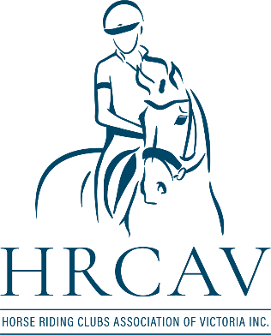

RULE CHANGE 19/3/26 – Effective Immediately

General Rules

THE HUNDRED POINT AWARD
The Hundred Point Award is attained by any Horse/Rider Combination who earns 100 competition points in the disciplines of Dressage, Combined Training, Showjumping, 3 Phase Equitation and Navigation Rides.

In Showing only, the Horse/Rider Combination must earn 300 competition points to be eligible for the Award.

In Horse Trials only, the Horse/Rider Combination must earn 50 competition points to be eligible for the Award.
- Points are Performance points gained for placing at Official HRCAV Events and DO NOT include points “assumed” when a Combination is Level Assessed.
- Members who have achieved the required points to qualify for the Award shall be identified by the HRCAV.
- The HRCAV Executive Committee will ratify the attainment of the Award and advise the Awardee in writing, including arrangements for presentation of the Award. A copy of the letter shall be forwarded to the winner’s Club Secretary.
- The Trophy for this Award will be to a value as determined by the Executive Committee and engraved as appropriate.
- Special Achievement Awards recognizing horse and rider combinations which fail to reach the required number of points due to unforeseen and tragic circumstances may be made under this category. There must be a reasonable expectation that achievement of the required number of points was imminent.
Rationale: Administrative – parts of current rule requirements outdated

Event Rules

Delete Rule 37.8 (d)

Add New Rule 37.8.1
If a vet is present at an event, the ground jury may request a spot vet check at any time before, during or after a combination has taken part in the event.
Rationale: Welfare/Clarification

