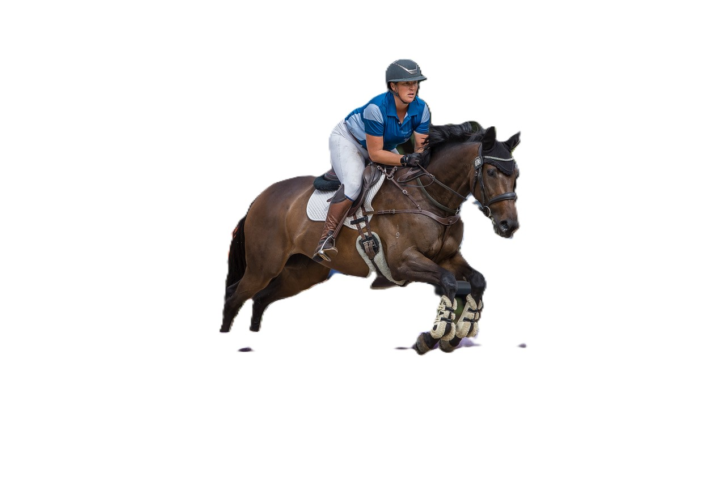

**Awards**

**Night**

**Saturday**

**15th November 2025**

@ 7pm

**Manningham Civic Centre**

699 Doncaster Road, Doncaster

*Dress Code – Semi Formal*

**Awards Being Presented**

**CHAMPION RIDER I TOP TEN I TOP CLUB I HUNDRED POINT I TOP THOROUGHBRED I TOP STANDARDBRED**

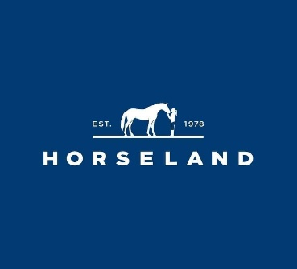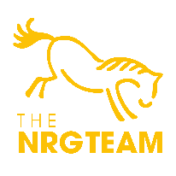

Cover Band on the Night

**Book Your Tickets via**

<https://eventsecretary.com.au/equestrian/>

RSVP 29 October 2025

**Tickets: $135 Per Person**

Includes Canapes & 2 Course Dinner. Beer, Wine & Soft Drinks provided.