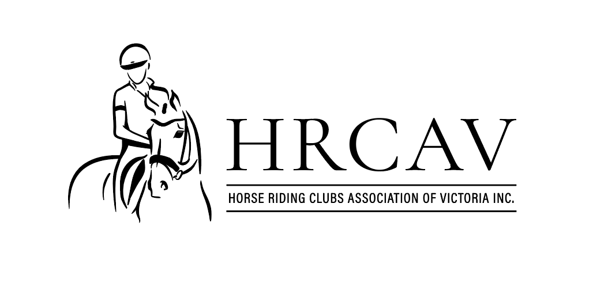
COVIDSAFE PLAN FOR HRCAV CLUBS
The COVIDSafe Plan for HRCAV Clubs has been developed to support Clubs to run COVIDSafe events and activities in line with any restrictions and to prepare for a suspected or confirmed case of coronavirus (COVID-19) at the venue.

In order to assist compliance with public health directions:
- All HRCAV Clubs must complete a COVIDSafe Plan.
- Your CovidSafe Plan must be reviewed regularly to ensure compliance with current restrictions.
- You must comply with a request to present or modify your COVIDSafe Plan, if directed to do so by the HRCAV, an authorised Govt Officer or Worksafe inspector.

How to develop your COVIDSafe Plan

Understand your responsibilities. While most government restrictions which affect our activities have been rescinded you still need to take steps to provide a CovidSafe environment.

Key areas to cover in your plan
- Social distancing. What steps will you take to avoid unnecessary gatherings?
- Enclosed spaces: What steps will you take to avoid unnecessary use of enclosed spaces? If enclosed spaces are used, how will you ensure there is sufficient ventilation?
- Hygiene. How will you encourage participants to follow good personal hygiene practices? What cleaning programs will you implement to maintain cleanliness of common areas?
- Symptomatic participants. What steps will you take to limit the likelihood of a symptomatic participant attending your activity? What action will you take if a participant presents with symptoms?
.

HRCAV CLUB SAFETY PLAN
Suggested risk mitigation strategies are included. Strategies shown in bold type are compulsory.
Draw a line through suggested processes which will not be implemented. Add further detail or additional processes in the space provided.

To be completed by HRCAV Clubs which conduct activities or events.
Copies to be provided to all members of the Organising/Club Committee.
Volunteers to be briefed on CovidSafe Plan/requirements.
Your Event Safety Plan must be provided to the HRCAV, Govt Authorised Officer or WorkSafe upon request

CLUB NAME

EVENT TYPE |  |  |  |  | DATE
COVID RISK MANAGEMENT COORDINATOR
EMAIL |  |  |  | PHONE
DATE LAST REVIEWED

- SOCIAL CONTACT
Action item | Action officer | Actioned
  - Hold meetings online if possible
  - Encourage social distancing
  - Schedule riders to keep numbers at venue manageable and facilitate social distancing
  - Implement pre entry/booking and payment for events and activities
  - Move activities outdoors when possible

EVENTS – additional strategies
  - Include a link to the standard CovidSafe conditions of entry on event programs https://hrcav.com.au/covidsafe-conditions-of-entry-for-competitions/ Add any venue specific conditions to your program.
  - Run a ‘No Cards’ Event
  - OTHER/DETAILS

- FACE MASKS
You must ensure all participants entering the venue comply with current public health advice re facemasks
Victoria
NSW
SA
Action item | Action officer | Actioned
  - Advise participants to wear facemasks in at risk situations (eg: canteen)
  - Advise participants to provide their own mask
  - Maintain stock of facemasks and other PPE for participants who do not have their own
  - Monitor use of facemasks at the event/activity in at risk situations
  - OTHER/DETAILS

- GOOD HYGIENE
Action item | Action officer | Actioned
  - Promote hand sanitising and personal hygiene measures on event website and information to participants
  - Provide hand sanitizing stations at common areas - toilets, gate, outside event office, food areas
  - Display signs and posters to encourage personal hygiene
  - OTHER/DETAILS

- COVID SYMPTOMS
Action item | Action officer | Actioned
  - Publicise participant responsibilities if they have Covid symptoms or are a close contact of a person with Covid19 https://www.coronavirus.vic.gov.au/checklist
  - Publicise advice that persons with Covid symptoms must not attend the event or activity
  - Include as a condition of entry that persons showing Covid symptoms will be required to leave the event.
  - Have a list of volunteers/officials who can step into a role to fill a vacancy in the event that someone is unable to attend.
  - OTHER/DETAILS

If a participant presents with symptoms consistent with COVID-19 (fever or respiratory symptoms such as cough, sore throat and shortness of breath)
Action item | Action officer | Actioned
  - Apply the following procedures. Ensure ready access to this information.
Notify the Covid Safety Officer
- Isolate: Remove the person from others. If person has serious symptoms such as difficulty breathing call 000.
- Remove: Mild symptoms (including elevated temperature of 37.5C or higher) person required to leave venue. Advise to seek medical advice.
- Inform: Advise the person of their responsibilities if they have Covid symptoms https://www.coronavirus.vic.gov.au/checklist
- Transport: Make sure the person has transport, either to their home or to a medical facility.
- Clean: Any indoor or common use area where the person has been. Personal Protective Equipment (PPE) should be used when cleaning.
- Identify: Determine if anyone had close contact with the infected person. Close contact means anyone who has been face-to-face for at least 15 minutes with the infected person or has been in the same space as them for two hours. Notify close contacts that they may have been exposed to the virus and advise them of their responsibilities https://www.coronavirus.vic.gov.au/checklist You must maintain the privacy of all individuals involved.

- AVOID INTERACTIONS IN ENCLOSED SPACES
Reduce the amount of time participants spend in enclosed spaces
Action item | Action officer | Actioned
  - Move activities outside where possible.

  - EVENTS – further actions
  - Event office:
- Have minimal personnel in office
- Minimise contact with participants
- Use of electronic systems where possible
- Run a ‘No Cards’ event – no need for riders to report to office

  - Scoring:
- Post scores live on-line or
- Situation scoreboards outdoors – spread them out
- Use electronic scoring systems if possible

  - Dressage Judging:
- If a penciller is required.
- Masks should be worn.
- Encourage air circulation in vehicle or box

  - OTHER/DETAILS:

- ADDITIONAL CONSIDERATIONS
What precautions are in place where food is provided?
Action items | Action Officer | Actioned
  - Food at rallies. Avoid sharing of food.

  - Canteen
  - Post signs re social distancing
  - Allow take-away only – no seating
  - Servers to wear masks and gloves
  - Provide a hand sanitising station
  - Include Canteen vouchers in entry to limit cash payments

  - Food van
  - Post signs re social distancing
  - Provide a hand sanitizing station

  - OTHER/DETAILS

What are your strategies to address non-compliance?
Action item | Action Officer | Actioned
  - Give warning/reminder by Club official/marshall/CSO
  - Eliminate from competition and request departure from venue
  - Refusal to leave venue following identification of symptoms – contact local police.
  - Report deliberate non-compliance to HRCAV for handling under Complaint Process
  - OTHER/DETAILS

What Covid Safe conditions of entry will be included on your event program?
Action item | Action officer | Actioned
  - Include a link to HRCAV standard conditions of entry of entry on program
  - Publicise other Event specific conditions (example)
    - no cards event
    - no camping / restrictions
    - electronic live scoreboard
  - OTHER / DETAILS

Have you checked with the venue owner/manager to determine specific venue requirements? Details
Action item | Action officer | Actioned
  - Check with venue owner. Some venues may have requirements in place
6.21 VENUE SPECIFIC REQUIREMENTS LISTED BELOW

POSITION DESCRIPTION - COVID SAFETY OFFICER

OVERVIEW
To keep HRCAV safe for participants, members, parents, volunteers, coaches, officials and spectators, and to ensure the safety of the wider community HRCAV strongly supports the appointment of a Club COVID Safe Officer.

The COVID Safe Officer will be of assistance in implementing a safe return to HRCAV activities.

It is recommended that this role is a ‘stand-alone’ role, however, can be combined with other duties that do not restrict the duties of the COVID Safe Officer.

SCOPE OF POSITION
Aim: To ensure HRCAV remains safe for all members.

Role: The COVID Safe Officer is responsible for implementing the club Covid Safety Plans (rallies and events) and to ensure that all the actions outlined are in place prior to an activity commencing.

NOTE: It is not the role of the COVID Safe Officer to write or develop a Covid Safety plan. That is the role of the club committee, however it would be reasonable to expect the COVID Safe Officer will have input into the development of the plan.

Extent: This role extends to all activity undertaken by the club: Rallies, Events, all other riding activity, and all non-riding activities including working bees. The club committee may appoint one or more COVID Safe Officers to ensure a presence at all activity. The COVID Safe Officer can delegate duties as required.

Reports to: Club Committee.

EXPERIENCE REQUIRED
Must be able to maintain an understanding of the club Covid Safety Plan as amended from time to time to reflect HRCAV template plans and state government requirements.

DUTIES:
- To ensure the club COVID Safety plan is in place and kept up to date.
- To attend event to monitor the implementation of the COVID Safety plan.
- Report instances of non-compliance to the committee. Committee is to deal with evictions of people who refuse to comply.
- Implement mandatory exclusion, that is, people who are displaying symptoms of being sick must be directed to leave the premises immediately.

